**Week 1 Discussion Forum 2 – Software Process Modeling**

Vicki Kelm

The University of Arizona Global Campus

CST 499: Capstone for Computer Software Technology

Dr. Amjad Alkilani

December 13, 2023

**Concept Map**

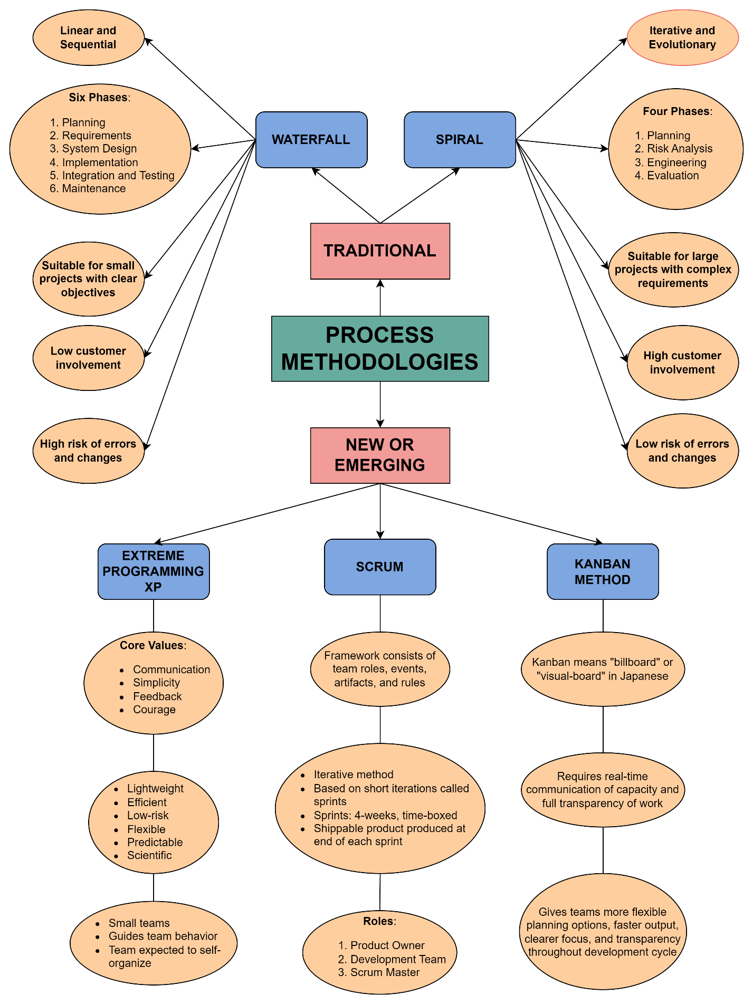

**Week 1 Discussion Forum 2 – Software Process Modeling**

Software process modelling “provides guidance for systematically coordinating and controlling the tasks that must be performed in order to achieve the end product and the project objectives” (Tsui, Karam, & Bernal, p. 57). This paper will include a developed concept map that shows the different process methodologies, traditional versus new or emerging, describe how agile process methodologies can better address current challenges for software development, and discuss the limitations of a traditional methodology.

**Describe how agile processes methodologies can better address current challenges for software development**

The agile method provides several benefits that better address current challenges for software development. One of these benefits is that its method works to develop software in smaller iterations to guarantee a finished product at all times. “Agile methods are extremely good at dealing with change” (Tsui, Karam, & Bernal, p. 85). This means that completed requirements do not need to specification at the beginning. Agile methods prioritize feedback and learning, promotes flexibility and collaboration. “The primary reason to move to agile planning is the reality is that we can’t plan our way around a world where there is constant disruption” (Varakantam, 2018). Agile provides a flexible, iterative development approach that aims to produce working products at the end of each cycle. Changes in scope and requirements are quickly adapted and incorporated during the next development iteration. Communication and feedback are consistent and productive proving to be a successful approach for the project. This method requires real-time communication of capacity and full transparency of work.

When thinking about adopting Agile process, there are some distinct advantages.

* **Low process complexity**: processes are simple, easily understood and implemented
* **Low cost and overhead**: mandate few activities that do not directly produce software
* **Efficient handling of changes**: processes designed assuming that requirements will change, method prepares for changes
* **Fast results**: fast iterations produces core system that can be used in short amount of time, continuous integration, final results faster
* **Usable systems**: customer involved, process deals with changes, final product is what customers actually want at project completion rather than original planned requirements

**Discuss the limitations of a traditional methodology**

Traditional methodology for software development has been proven to be very successful when applied to projects. However, they also have presented several types of problems that include the following based on the course text:

* **Lengthy development times**: project lengths range from one to five years
* **Inability to cope with changing requirements**: does not handle changing requirements very well
* **Assumption that requirements are completely understood before the project begins**: often unstated assumption, most users not capable of expressing requirements in clear and unambiguous language, typically not sure what they want, requirements typically are incomplete and incorrect
* **Too much reliance on heroic developer effort**: dependence on extra development effort to finish on time, productivity declines, leads to even longer hours
* **Complex methodology**: understanding methodology is time consuming, most are unable to afford to become experts
* **Waste/duplication of effort**: risk of information not being synchronized, tool support can minimize duplication, allowing for keeping and modifying information once and generate different views

The focus of both traditional and agile methodologies is that they both revolve around the development of strategies that promote team success, however, they both utilize very different approaches. The method to use, whether traditional or agile “depends on the type of project, its complexity, and the desired outcome” (Dehoyos, 2020). This paper includes a developed concept map that shows the different process methodologies, traditional versus new or emerging, described how agile process methodologies can better address current challenges for software development, and discussed the limitations of a traditional methodology.

**References**

Dehoyos, M. (2020, February 26). *The Differences between Traditional and Agile Project Management*. <https://www.agileconnection.com/article/differences-between-traditional-and-agile-project-management>

Tsui, F., Karam, O., & Bernal, B. (2018). [Essentials of software engineering](https://uagc.instructure.com/courses/126521/modules/items/6439323)(4th ed.). Jones & Bartlett Learning.

Varakantam, R. (2018, March 30). 6 differences between agile and traditional planning. <https://opensource.com/article/18/3/traditional-vs-agile-planning>